23F-0706

SDA Assignment # 03:

Sate Diagram:

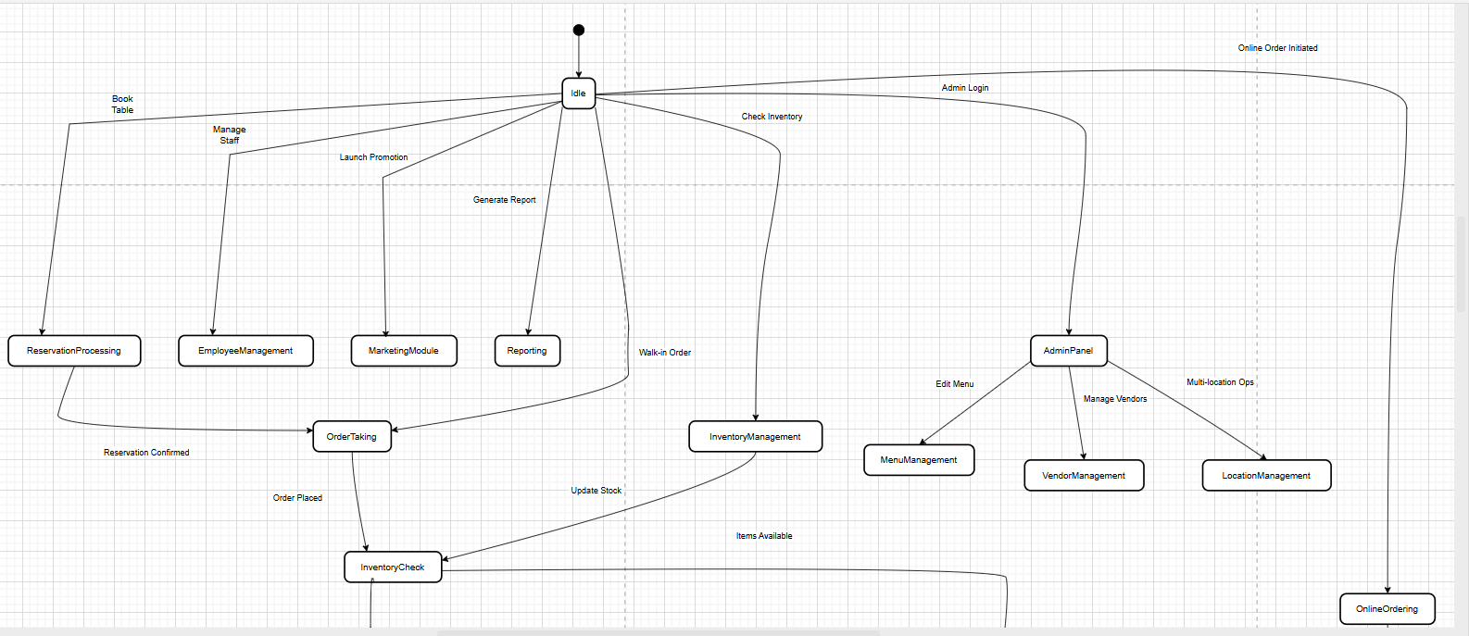

DFD

Level 0:

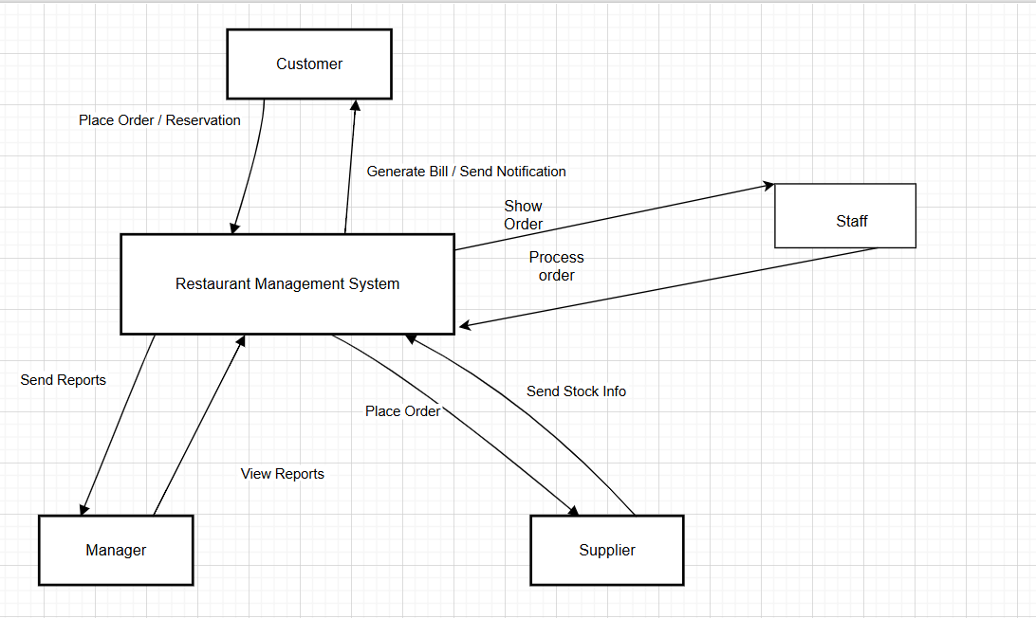

Level 1:

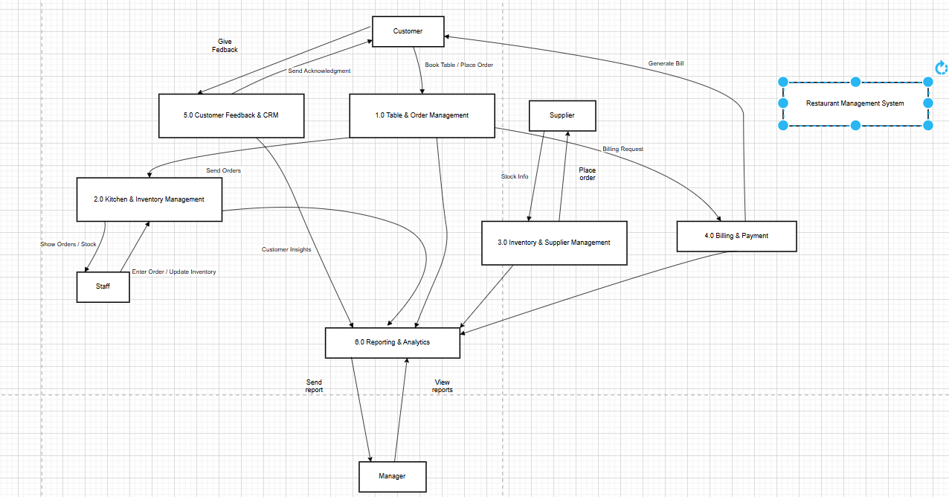

Level 2:

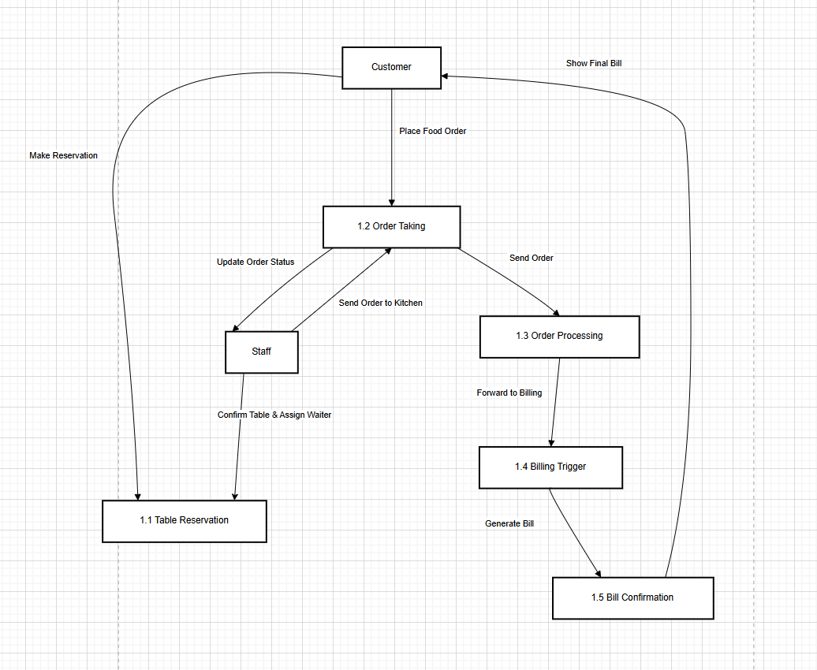

Component diagram

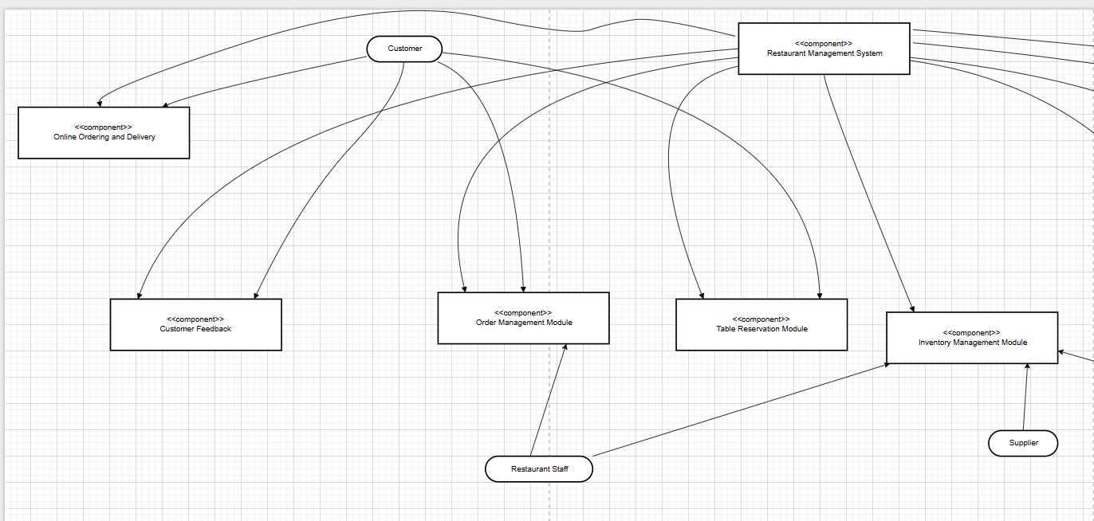

Package diagram

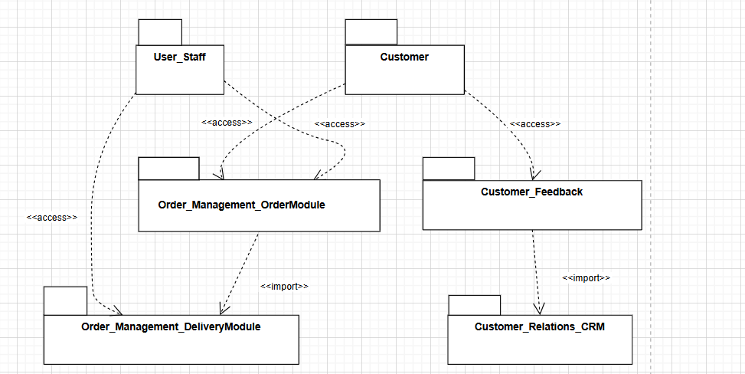

Deployment diagram

